Midterm PREP Script 1

Question 12 3

Quesition 20 4

Question 21 4

Question 22 4

Example 7.2 from Nise 5

Example 7.3 from Nise 6

Example 7.4 from Nise 6

Chapter 7 or 8 root Locus Plots 11

## Midterm PREP Script

Chapter 6 --- Stabability Question 1, Nise Textbook

clear all  
close all

s^5 +3s^4+5s^3 + 4s^2+s+3

polyVector = [1 3 5 4 1 3]  
RouthHurwitz(polyVector)

polyVector =  
  
 1 3 5 4 1 3  
  
  
 Routh-Hurwitz Table:  
  
rhTable =  
  
 1.0000 5.0000 1.0000  
 3.0000 4.0000 3.0000  
 3.6667 0 0  
 4.0000 3.0000 0  
 -2.7500 0 0  
 3.0000 0 0  
  
~~~~~> it is an unstable system! <~~~~~  
  
 Number of right hand side poles = 2  
  
 Given polynomial coefficients roots :  
  
sysRoots =  
  
 -1.6313 + 0.0000i  
 -0.9407 + 1.5042i  
 -0.9407 - 1.5042i  
 0.2563 + 0.7201i  
 0.2563 - 0.7201i  
  
  
ans =  
  
 1.0000 5.0000 1.0000  
 3.0000 4.0000 3.0000  
 3.6667 0 0  
 4.0000 3.0000 0  
 -2.7500 0 0  
 3.0000 0 0

Q2

v2 = [1 0 6 5 8 20]  
RouthHurwitz(v2)

v2 =  
  
 1 0 6 5 8 20  
  
  
 Routh-Hurwitz Table:  
  
rhTable =  
  
 1 6 8  
 0 5 20  
 -Inf -Inf 0  
 NaN NaN 0  
 NaN NaN 0  
 NaN NaN 0  
  
~~~~~> it is a stable system! <~~~~~  
  
 Number of right hand side poles = 0  
  
 Given polynomial coefficients roots :  
  
sysRoots =  
  
 0.6641 + 1.8230i  
 0.6641 - 1.8230i  
 -0.0000 + 2.0000i  
 -0.0000 - 2.0000i  
 -1.3283 + 0.0000i  
  
  
ans =  
  
 1 6 8  
 0 5 20  
 -Inf -Inf 0  
 NaN NaN 0  
 NaN NaN 0  
 NaN NaN 0

syms s  
(s+1)*(s+2)*(s+3)*(s+4)

ans =  
   
(s + 1)*(s + 2)*(s + 3)*(s + 4)

syms a b c EPS;

syms a b c EPS;  
ra=routh([1 a b c],EPS)

ra =  
   
[ 1, b]  
[ a, c]  
[ -(c - a*b)/a, 0]  
[ c, 0]

## Question 12

K(s+2)/s(s-1)(s+3)

syms s K EPS;  
ra2 = routh([1 2 K-3 2],EPS)

ra2 =  
   
[ 1, K - 3]  
[ 2, 2]  
[ K - 4, 0]  
[ (2*K - 8)/(K - 4), 0]

## Quesition 20

ra3 = routh([K+1 3 2+K],EPS)

ra3 =  
   
[ K + 1, K + 2]  
[ 3, 0]  
[ K + 2, 0]

## Question 21

ra4 = routh([1 5 4+K 6*K],EPS)  
% solve(4 - K/5==0)  
% solve((6*K*(K - 20))/(5*(K/5 - 4))==0)

ra4 =  
   
[ 1, K + 4]  
[ 5, 6*K]  
[ 4 - K/5, 0]  
[ (6*K*(K - 20))/(5*(K/5 - 4)), 0]

## Question 22

syms a b c EPS;  
ra5 = routh([1 K-b -a],EPS)

ra5 =  
   
[ 1, -a]  
[ K - b, 0]  
[ -a, 0]

## Example 7.2 from Nise

syms s  
Gs = 120*(s+2)/((s+3)*(s+4))  
CSlashR = simplify(Gs/(1+Gs))  
polyVector = [1 127 252]  
routh([1 127 252],EPS)  
limit(Gs,s,0)  
limit(s*Gs,s,0)  
  
limit(s^2*Gs,s,0)

Gs =  
   
(120*s + 240)/((s + 3)*(s + 4))  
   
   
CSlashR =  
   
(120*s + 240)/(s^2 + 127*s + 252)  
   
  
polyVector =  
  
 1 127 252  
  
   
ans =  
   
[ 1, 252]  
[ 127, 0]  
[ 252, 0]  
   
   
ans =  
   
20  
   
   
ans =  
   
0  
   
   
ans =  
   
0

## Example 7.3 from Nise

syms s  
Gs =100*(s+2)*(s+6)/(s*(s+3)*(s+4))  
CSlashR = simplify(Gs/(1+Gs))  
polyVector = [1 107 812 1200]  
routh(polyVector, EPS)  
%R(s) = 5*1/s  
limit(5/(1+Gs),s,0)

Gs =  
   
((100*s + 200)*(s + 6))/(s*(s + 3)*(s + 4))  
   
   
CSlashR =  
   
(100*s^2 + 800*s + 1200)/(s^3 + 107*s^2 + 812*s + 1200)  
   
  
polyVector =  
  
 1 107 812 1200  
  
   
ans =  
   
[ 1, 812]  
[ 107, 1200]  
[ 85684/107, 0]  
[ 1200, 0]  
   
   
ans =  
   
0

## Example 7.4 from Nise

Gs = 10*(s+20)*(s+30)/((s*(s+25)*(s+35)))  
CSlashR = simplify(Gs/(1+Gs))  
polyVector = [1 70 1375 600]  
routh(polyVector, EPS)

Gs =  
   
((10*s + 200)*(s + 30))/(s*(s + 25)*(s + 35))  
   
   
CSlashR =  
   
(10*s^2 + 500*s + 6000)/(s^3 + 70*s^2 + 1375*s + 6000)  
   
  
polyVector =  
  
 1 70 1375 600  
  
   
ans =  
   
[ 1, 1375]  
[ 70, 600]  
[ 9565/7, 0]  
[ 600, 0]

Gs = 10*(s+20)*(s+30)/((s^2*(s+25)*(s+35)*(s+50)))  
CSlashR = simplify(Gs/(1+Gs))  
polyVector = [1 110 3875 43760 500 6000]  
routh(polyVector, EPS)

Gs =  
   
((10*s + 200)*(s + 30))/(s^2*(s + 25)*(s + 35)*(s + 50))  
   
   
CSlashR =  
   
(10*s^2 + 500*s + 6000)/(s^5 + 110*s^4 + 3875*s^3 + 43760*s^2 + 500*s + 6000)  
   
  
polyVector =  
  
 1 110 3875 43760 500 6000  
  
   
ans =  
   
[ 1, 3875, 500]  
[ 110, 43760, 6000]  
[ 38249/11, 4900/11, 0]  
[ 1673237240/38249, 6000, 0]  
[ -1316030750/41830931, 0, 0]  
[ 6000, 0, 0]

G1(s) = 500*(s+2)*(s+5)/((s+8)*(s+10)*(s+12))  
G2(s) = 500*(s+5)*(s+5)*(s+6)/(s*(s+8)*(s+10)*(s+12))  
G3(s) = 500*(s+2)*(s+4)*(s+5)*(s+6)*(s+7)/(s^2*(s+8)*(s+10)*(s+12))  
Func1 = (simplify(G1(s)/(1+G1(s))))  
Func2 = (simplify(G2(s)/(1+G2(s))))  
Func3 = (simplify(G3(s)/(1+G3(s))))

G1(s) =  
   
((500*s + 1000)*(s + 5))/((s + 8)*(s + 10)*(s + 12))  
   
   
G2(s) =  
   
((500*s + 2500)*(s + 5)*(s + 6))/(s*(s + 8)*(s + 10)*(s + 12))  
   
   
G3(s) =  
   
((500*s + 1000)*(s + 4)*(s + 5)*(s + 6)*(s + 7))/(s^2*(s + 8)*(s + 10)*(s + 12))  
   
   
Func1 =  
   
(500*s^2 + 3500*s + 5000)/(s^3 + 530*s^2 + 3796*s + 5960)  
   
   
Func2 =  
   
(500*(s + 5)^2*(s + 6))/(s^4 + 530*s^3 + 8296*s^2 + 43460*s + 75000)  
   
   
Func3 =  
   
(500*s^5 + 12000*s^4 + 111500*s^3 + 498000*s^2 + 1058000*s + 840000)/(501*s^5 + 12030*s^4 + 111796*s^3 + 498960*s^2 + 1058000*s + 840000)

[n1,d1] = numden(Func1)  
routh(sym2poly(d1), EPS)  
[n2,d2] = numden(Func2)  
routh(sym2poly(d2), EPS)  
[n3,d3] = numden(Func3)  
routh(sym2poly(d3), EPS)  
  
Kp = limit(G1(s),s,0)  
Kv = limit(s*G2(s),s,0)  
Ka = limit(s^2*G3(s),s,0)

n1 =  
   
500*s^2 + 3500*s + 5000  
   
   
d1 =  
   
s^3 + 530*s^2 + 3796*s + 5960  
   
   
ans =  
   
[ 1, 3796]  
[ 530, 5960]  
[ 200592/53, 0]  
[ 5960, 0]  
   
   
n2 =  
   
500*(s + 5)^2*(s + 6)  
   
   
d2 =  
   
s^4 + 530*s^3 + 8296*s^2 + 43460*s + 75000  
   
   
ans =  
   
[ 1, 8296, 75000]  
[ 530, 43460, 0]  
[ 8214, 75000, 0]  
[ 52871740/1369, 0, 0]  
[ 75000, 0, 0]  
   
   
n3 =  
   
500*s^5 + 12000*s^4 + 111500*s^3 + 498000*s^2 + 1058000*s + 840000  
   
   
d3 =  
   
501*s^5 + 12030*s^4 + 111796*s^3 + 498960*s^2 + 1058000*s + 840000  
   
   
ans =  
   
[ 501, 111796, 1058000]  
[ 12030, 498960, 840000]  
[ 36497564/401, 410230000/401, 0]  
[ 3318939408360/9124391, 840000, 0]  
[ 22481158689222000/27657828403, 0, 0]  
[ 840000, 0, 0]  
   
   
Kp =  
   
125/24  
   
   
Kv =  
   
625/8  
   
   
Ka =  
   
875

Try

numg=1000*[1 8];  
deng=poly([-7 -9]);  
G=tf(numg,deng);  
Kp=dcgain(G)  
estep=1/(1+Kp)  
T=feedback(G,1);  
poles=pole(T)

Kp =  
  
 126.9841  
  
  
estep =  
  
 0.0078  
  
  
poles =  
  
 1.0e+03 *  
  
 -1.0080  
 -0.0080

## Chapter 7 or 8 root Locus Plots

Root Locus Plot

h = tf([2 5 1],[1 2 3]);  
rlocus(h)  
snapnow;

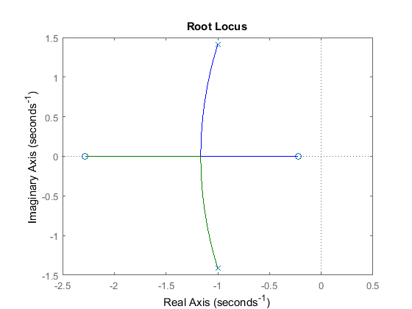

Example from textbook

syms s  
x = s*(s+1)*(s+2)*(s+4)  
den = sym2poly(x)  
num = (s+3)  
num = sym2poly(num)  
h = tf([num],[den])  
rlocus(h)

x =  
   
s*(s + 1)*(s + 2)*(s + 4)  
   
  
den =  
  
 1 7 14 8 0  
  
   
num =  
   
s + 3  
   
  
num =  
  
 1 3  
  
  
h =  
   
 s + 3  
 --------------------------  
 s^4 + 7 s^3 + 14 s^2 + 8 s  
   
Continuous-time transfer function.

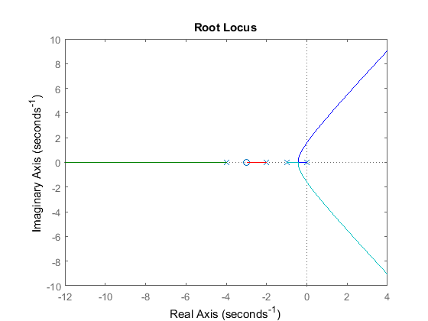

$$ $$

x = (s+2)*(s+4)*(s+6)  
den = sym2poly(x)  
h = tf([1],[den])  
rlocus(h)

x =  
   
(s + 2)*(s + 4)*(s + 6)  
   
  
den =  
  
 1 12 44 48  
  
  
h =  
   
 1  
 ------------------------  
 s^3 + 12 s^2 + 44 s + 48  
   
Continuous-time transfer function.

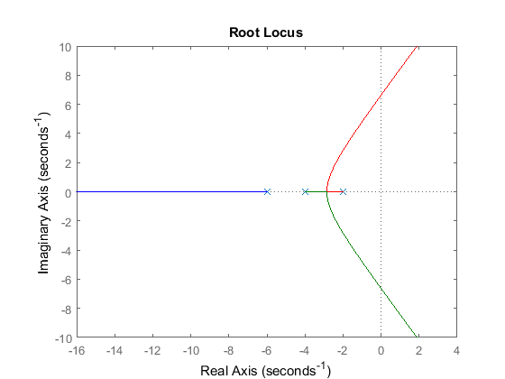

syms s K EPS  
x =s^4+ 7*s^3+14*s^2+(8+K)*s+3*K  
polyVec = [1 7 14 8+K 3*K]  
xD = routh(polyVec, EPS)  
xD = simplify(xD)

x =  
   
s^4 + 7*s^3 + 14*s^2 + (K + 8)*s + 3*K  
   
   
polyVec =  
   
[ 1, 7, 14, K + 8, 3*K]  
   
   
xD =  
   
[ 1, 14, 3*K]  
[ 7, K + 8, 0]  
[ 90/7 - K/7, 3*K, 0]  
[ (K^2/7 + (65*K)/7 - 720/7)/(K/7 - 90/7), 0, 0]  
[ (3*K*(K/7 - 90/7)*(K^2 + 65*K - 720))/((K - 90)*(K^2/7 + (65*K)/7 - 720/7)), 0, 0]  
   
   
xD =  
   
[ 1, 14, 3*K]  
[ 7, K + 8, 0]  
[ 90/7 - K/7, 3*K, 0]  
[ (K^2 + 65*K - 720)/(K - 90), 0, 0]  
[ 3*K, 0, 0]

polyVec = [1 6 8]  
routh(polyVec,EPS)  
% stable function  
rlocus(tf([1 4 20],[1 6 8]))

polyVec =  
  
 1 6 8  
  
   
ans =  
   
[ 1, 8]  
[ 6, 0]  
[ 8, 0]

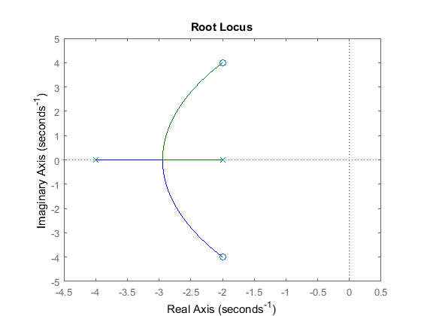

Question 8--4

num= tf([1 2/3])  
den = tf([1 6 0 0])  
  
sys = tf([1 2/3], [1 6 0 0])  
rlocus(sys)

num =  
   
 From input 1 to output:  
 1  
   
 From input 2 to output:  
 0.6667  
   
Static gain.  
  
  
den =  
   
 From input 1 to output:  
 1  
   
 From input 2 to output:  
 6  
   
 From input 3 to output:  
 0  
   
 From input 4 to output:  
 0  
   
Static gain.  
  
  
sys =  
   
 s + 0.6667  
 -----------  
 s^3 + 6 s^2  
   
Continuous-time transfer function.

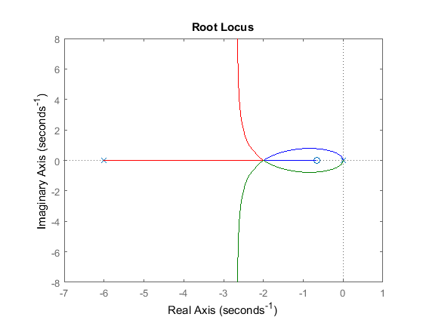

[Published with MATLAB® R2017a](http://www.mathworks.com/products/matlab)